The Hindmarsh Hall

Annual General Meeting

Monday 30th May 2022 7.00 p.m.
1. Welcome and Apologies
The Chair, Elaine Stead, welcomed attendees to the AGM. Apologies were received from Giles Arthur, Martha Hitchcock, Joan Robson, Martin Swinbank and Katherine Williams.
2. Present: Bill Bourne, Hilda Blythe, David Denton, Judy Woodford, Sally Wilson, Nikki Brierley and Elaine Stead (Hindmarsh Hall Trustees), Kathryn Archibald, Claire Smith, Di Spark and Kathryn Brunton (Alnmouth WI), Shaun Whyte, Ian Campbell, Susanne Gair and Simon Walford (Alnmouth Parish Council), Joan Davison, Jonathan Letchfield, Pam Muggleton and Nigel Stead (residents).
3. Minutes of the AGM 7th September 2021
The meeting considered the minutes of the previous AGM held on 7th September 2021. It was moved that these be accepted and this was seconded from the floor.
4. Matters Arising
There were no matters for discussion.
5. Chair’s report and presentation of plans for Storage Extension
“At the last AGM, delayed by COVID until September 2021, the then Chair, Bill Bourne, explained how we had used the period of the pandemic, when the Hall was closed, to embark on an ambitious programme of building works and refurbishment which has created this magnificent venue we are in today. I’m sure you’ll all agree that the generosity and hard work of so many people has been well rewarded. Alnmouth has a wonderful village hall, not just to enjoy but to be proud of.
Much of the refurbishment work was done in the first 4 months of this financial year. On April 1st 2021 Ann and Jack Ross, long standing residents of the village, placed a time capsule under the new floor of the upper hall. This seemed to mark the end of the beginning of the refurbishment process and thereafter it was wonderful to see everything coming together. We reopened on August 1st when Councillor Gordon Castle did the honours. Then we were up and running. For those of us who have been involved in this transformation, it has been really pleasing to see so many regular groups coming back to the Hall, new groups using the facilities and the building being hired for private events. The feedback from users and hirers has been really positive. Since we opened in September last year we have had over 1,000 people passing through the building each month, an astonishing number.
We are pleased also that the range of activities available at the Hall is widening, with a new Scouting group, Squirrels, for 4 and 5 year olds and also the Phoenix Club for retired residents where a mixed group of men and women enjoy a chat with a cup of tea, a game of bridge, dominoes or whatever new game comes out of John Hall’s bag. The Trustees are proud to support this group from Hall Funds as the Hindmarsh Hall’s central role is to be here for the community of Alnmouth. Following Storm Arwen the Hall provided hot drinks, food, warmth and battery charging for local people who suffered long power cuts.
Since re-opening there have been special events almost every week - concerts, talks, workshops, art fairs and theatre productions. We hope that you have found something in the long list of events to entertain you and we welcome suggestions for other events that might prove popular in the village.
Judy Woodford, our treasurer, will give you the detail shortly, but suffice to say that financially we are pleased that after completing the refurbishment of the upper hall, taking the opportunity to make repairs to the roof and guttering while scaffolding was in place, and replacing tired items in the kitchen, we have sufficient surplus to make plans to embark on our next phase of improvements, of which more later. This is due to some hard but very successful work by our events team, headed by Maureen Bickerdike, and our grant fund raising team led by Hilda Blythe. I would also like to make a special mention of the input of our Bookings Secretary, Sally Wilson. She is the heart and soul of the Hindmarsh Hall. Our full calendar of lettings, events and functions is testimony to her hard work, but she also works tirelessly showing prospective users round the hall and her marshalling of the furniture upstairs and downstairs is simply heroic.
In the year to April 2021 we had little contact with the village because of COVID and we used whatever means of communication we could to keep the community informed of what was going on, including the first editions of The Hindmarsh Hall Times, delivered to all households in the village. Since then we have continued to use many different types of media to spread the word about our events and classes and our developments, using Facebook, our website, Instagram, posters in the village, the Parish Council newsletter and the Bridge magazine. We hope that by these means we are reaching our community. We have 728 followers on Facebook and 240 on Instagram. This last from a standing start in January.
We are pleased and proud of what we have achieved in the last 12 months, but this is not really my report. For 11 of the 12 months, Hilda Blythe held the chair. Hilda’s drive and enthusiasm for the Hall has helped to motivate others and I would personally like to pay tribute to all that Hilda has done over very many years, and still does, for the Hall. In addition I would like to pay tribute to all the trustees sitting here tonight. They are a wonderful team, each with their own personal skills that they bring to Hall and that mix of skills has enabled us to achieve what you see and what you read about. Thanks are also due to Tom Batey, who has continued to project manage our works and to Giles Arthur, architect and resident of High Buston who has given his expertise without charge, creating plans and drawings and submitting them to the planners. Without these two, I simply say, we would have struggled.
Teams evolve, times change and we always need new blood and new ideas. If any of you would like to become a trustee we welcome you. Don’t think you might not have the necessary skills. We all have our own particular skills and we need a range of them. A team of cake bakers wouldn’t be enough. Please come forward if you are interested or let us know if you think others might be.
Future Plans
When the renovation work to this upper Hall was planned over 4 years ago, a key component of those plans was to build an extension for storage in the yard at the back of the building. Removal of the stage would mean that all those things that were stored on or underneath it would need a new home. The plans submitted and approved in 2018 included this extension. When the hall reopened last August, Bill told us how, when the renovations began it was found that the state of the east wall was far worse than we thought. It was bulging out into the yard and the inner leaf of stonework needed to be rebuilt. This become a priority and the opportunity of COVID, forcing the hall to close, meant we could crack on with the work refurbishing it in time to reopen when COVID restrictions were lifted. The building of the extension was put on the back burner.
Our proposals are that the shed in the yard will be removed and an extension built maximising the space available in the yard behind the hall. There will be access directly from the lower hall, all on one level so that trolleys of chairs or tables can be moved into the extension with ease. There will be roof lights in the extension so that light can still get into the lower hall through the windows. The connecting door will be glazed with glazed panels either side, maximising the light.
So the $64,000 question – how much will this cost? It won’t be cheap – extensions to Grade II listed buildings never are, but this is a generational improvement, designed to last and transform the way the building is used. Because of the costs, we plan to work in phases. Phase 1 is the important one, building the extension. Tom Batey has given us some figures and we are looking at just short of £50,000 for this phase. The good news is that we already have sufficient funds to proceed with the groundworks and stabilising of the stone walls surrounding the yard this summer while hopefully the weather is good. This work won’t affect the use of the Hall. After that we can proceed with the building itself as and when we have sufficient funds.
The next phase, again to be completed as and when we have funds, is the refurbishment of the lower hall. Much of this work will be necessary to make good from building the extension. But funds allowing, we would like to bring to room up to the same standard as the upper hall with double glazing and new flooring etc. and we would also like to make provision for displaying some of the heritage material stored upstairs. Phase 3 is replacing the lift. Many of you will know of the unreliability of the lift which is now more than 20 years old. And whilst we are applying for funding we thought we would take the opportunity to add this to our wish list.
We have applied to a number of funders already and so far we have £24,449. We are still waiting to hear from further funders and are about to start a second round of applications. As I said earlier, this is a phased campaign and we will do the work as and when we have funds.
At this point I should mention that the Secret Gardens event yesterday raised over £2,000, a staggering amount. A good proportion of these funds will go towards the extension. The Trustees are hugely grateful to Shian Hartshorn for organising this event for the Hall.
The situation we are trying to rectify is that of storing tables and surplus chairs around rooms which are in use. We need to make the hall an easy place to use, it is unfair to expect Trustees to be constantly moving furniture around. When built the extension will allow easy storage, no longer in corners of rooms and all on the level. This is how the finished extension might look from the outside.
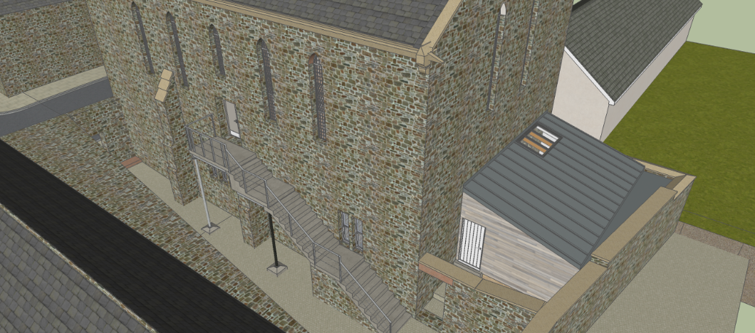

Questions from attendees
- What is the height and width of the proposed new storage unit?
Elaine Stead referred back to the plans explaining that the extension would be wider than the lower hall and fill the yard from front to back as shown in the drawing above.
- Would all tables were to be kept in the new storage unit?
It was explained that the circular tables would likely remain in the Upper Hall and only put in the storage unit should there be a special event when they were not required.
6. Treasurer’s Report
Judy Woodford presented the Treasurers Report (See Appendix1)
7. Appointment of Examiner of the Accounts for 2022 2023
It was moved and seconded from the floor that “Greaves Grindle” of Alnwick be appointed as auditors for the accounts 2022/2023.
8. Election 2022/2023 Management Committee
All current Trustees retired and were all re-elected.
Jonathan Letchfield was nominated as a new Trustee and this was seconded.
9. Questions were invited from the floor
1. Would it be possible for small local events to have discretionary rates?
Sally Wilson explained that regular users already received discretionary rates and that the current rates were in keeping with those of other local village halls. All efforts were made to keep the rental charges as low as possible and they were used to pay for the running costs of the Hindmarsh Hall. Elaine Stead explained that the Trustees’ prime responsibility is to the upkeep of the Hall for the community, and therefore as a charity itself it is inappropriate to give financial assistance to other charities or organisations.
2. Where are the hiring rates published?
Elaine Stead explained that these were on the Hindmarsh Hall website in the section “Hire the Hall”
- Could these rates be published on the Hindmarsh Hall Noticeboard?
This was agreed to be a good idea and Trustees would action this.
- How are the annual costs calculated?
Running costs are calculated and are paid by the general rentals. Fundraising events are used to replace equipment and go towards renovation costs.
N.B.
During the meeting some of the attendees left to attend a “Woman’s Institute” meeting. At this point Kathryn Archibald Chair of the WI wanted it to be put on record that the WI appreciate the work of the Trustees and enjoy using the newly refurbished space in the Upper Hall.
There being no further comments, Elaine Stead thanked everyone for coming and closed the meeting at 7.45 p.m.
Appendix 1
HINDMARSH HALL
TREASURERS REPORT
YEAR ENDED 31ST MARCH 2022

The accounting year to 31st March 2022 has been another strange year. We did not open fully until September 2021 when the Covid restrictions had been lifted. However, thanks to Sally’s hard work we received £4,585 in regular rents and £4,579 in miscellaneous rents.
Thanks to the hard work of the fund-raising committee, we managed to hold several fund-raising events and took nearly £10k
Also, thanks to Hilda and Elaine for managing to secure grants of £47,400, all of which have been allocated to the restoration and new equipment for the Hall. Including the new tables, chairs, trolleys, blinds, projector, double glazing, scaffolding and fire escape. The double glazing should be completed in June.
The produce stall and plant sale raised an incredible £3,381 Thanks to all who put in time and effort to produce such amazing results.
We have taken out a £20K loan to go towards the additional expenditure needed to continue with the building works on the Hall.
In total we have spent over £72K from the restricted funds and over £22k from our general funds on the building works alone in this financial year
As expected, after reopening our expenditure on running cost of the hall have increased this year. The light and heating alone have increased by nearly £1,400 this year, these in charges are lightly to increase again next year. I expect our rents will have to increase again next year to cover the extra costs.
As well as the extra amount spent from the general account on the restoration works, we had to buy a new dishwasher and extractor fan for the kitchen which cost nearly £5,800.
At the end of the financial year, we held £6,342 (2021: £18,155) in the general fund and £13,445 (2021: £49,350) in the restricted fund
The Trustees have agreed the Hindmarsh Village Hall accounts which will be published on the Charity Commission website that is available for anyone to see.

